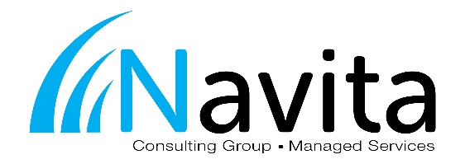
Job Title: Network Administrator
Department: Service and Support Reports to: Service Manager

GENERAL SUMMARY:
The Network Administrator is responsible for maintaining the design and integrity of the systems, as well as providing technical assistance to team members with system and network requests.

Essential Duties and Responsibilities:
- IT Support relating to issues with the systems and network infrastructure
- Support services for Microsoft related technologies: Windows Server, Exchange, SQL, SharePoint, etc.
- Support services for virtualization technologies: VMware, Citrix, and Microsoft
- Technical services and support at the network level: WAN and LAN connectivity, routers, firewalls, and security
- Administer hosted and cloud solutions for customers using technologies that meet their requirements
- Support disaster recovery solutions
- Remote access solution support: VPN, Terminal Services, and Citrix
- Monitor the remote monitoring and management system alerts and notifications, and respond accordingly through service tickets
- Administration and maintenance of the remote monitoring and management system: update agent scripts, respond to alerts, monitor dashboard, and periodic system review
- Document maintenance for all computer systems and network infrastructure
- Communication with customers as required: keeping them informed of incident progress, notifying them of impending changes or agreed outages

Additional Duties and Responsibilities:
- Improve customer service, perception, and satisfaction
- Ability to work in a team and communicate effectively
- Escalate service or project issues that cannot be completed within agreed service levels
- Business awareness: specific knowledge of the customer and how IT relates to their business strategy and goals
- Document internal processes and procedures related to duties and responsibilities
- Responsible for entering time and expenses in ConnectWise as it occurs
- Understand processes in ConnectWise by completing assigned training materials and blueprints on the ConnectWise University
- Work through a daily schedule in ConnectWise that has been established through the dispatch process
- Work through project tickets and phases in ConnectWise as assigned by a Project Manager
- Enter all work as service or project tickets into ConnectWise
- Review IT publications and online materials to remain up-to-date with current and future technologies emerging in the industry

Knowledge, Skills, and/or Abilities Required:
To perform this job successfully, an individual must be able to perform each essential duty satisfactorily. The requirements listed below are representative of the knowledge, skill, and/or ability required. Reasonable accommodations may be made to enable individuals with disabilities to perform the essential functions.
- Professional IT Certifications, such as: Microsoft MCP, MCSA, or MCSE, Citrix CCEA or CCIA, SonicWall CSSA, Cisco CCNA, or VMware VCP
- Interpersonal skills: such as telephony skills, communication skills, active listening and customer-care
- Diagnosis skills of technical issues
- Ability to multi-task and adapt to changes quickly
- Technical awareness: ability to match resources to technical issues appropriately
- Service awareness of all organization’s key IT services for which support is being provided
- Understanding of support tools, techniques, and how technology is used to provide IT services
- Typing skills to ensure quick and accurate entry of service request details
- Self-motivated with the ability to work in a fast moving environment

