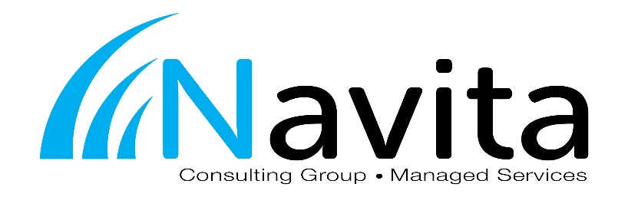
Job Title: Service Desk Technician
Department: Service and Support Reports to: Service Manager

GENERAL SUMMARY:
The Service Desk Technician is responsible for handling first level support of service requests. This relates to all technology, to include: workstations, servers, printers, networks, and vendor specific hardware and software.

Essential Duties and Responsibilities:
- IT Support relating to technical issues involving Microsoft’s core business applications and operating systems
- Support of disaster recovery solutions
- Basic technical support at the network level: WAN and LAN connectivity, routers, firewalls, and security
- Basic remote access solution implementation and support: VPN, Terminal Services, and Citrix
- Monitor the remote monitoring and management system alerts and notifications, and respond accordingly through service tickets
- System documentation maintenance and review in ConnectWise
- Communication with customers as required: keeping them informed of incident progress, notifying them of impending changes or agreed outages

Additional Duties and Responsibilities:
- Improve customer service, perception, and satisfaction
- Fast turnaround of customer requests
- Ability to work in a team and communicate effectively
- Work with the Service Desk Dispatcher to ensure requests are routed to the proper resource in order to be resolved quickly and efficiently
- Escalate service requests that require engineer level support
- Responsible for entering time and expenses in ConnectWise as it occurs
- Understand processes in ConnectWise by completing assigned training materials and blueprints on the ConnectWise University
- Enter all work as service tickets into ConnectWise

Knowledge, Skills, and/or Abilities Required:
To perform this job successfully, an individual must be able to perform each essential duty satisfactorily. The requirements listed below are representative of the knowledge, skill, and/or ability required.

- Advanced understanding of operating systems, business applications, printing systems, and network systems
- Interpersonal skills: such as telephony skills, communication skills, active listening and customer-care
- Diagnosis skills of technical issues
- Ability to multi-task and adapt to changes quickly
- Technical awareness: ability to match resources to technical issues appropriately
- Service awareness of all organization’s key IT services for which support is being provided
- Understanding of support tools, techniques, and how technology is used to provide IT services
- Typing skills to ensure quick and accurate entry of service request details
- Self-motivated with the ability to work in a fast moving environment

